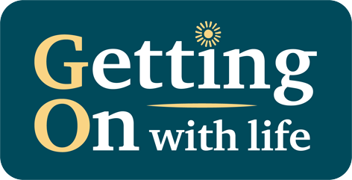

Week 1 Personalised Summary

Date:

Dear
Hello

Yours Sincerely

Link Worker

